**ASSIGNMENT 11.1**

**Question: Write the Pig codes to analyze the petroleum data set. https://github.com/prateekATacadgild/mAPrEDuce/commit/7f78340c5d59d22940587bb76bec 94dd4781265f**

**DATA SET DESCRIPTION**

**Column 1:** District ID I4N 1M1 varchar

**Column 2:** Distributor name shell varchar

**Column 3:** Buy rate (million) $957.70 varchar

**Column 4:** Sell rate(million) $5779.92 varchar

**Column 5:** volume IN(million cubic litre) 933, int

**Column 6:** volume OUT(million cubic litre) 843, int

**Column 7:** Year 1624 int

1. **What is the total amount of petrol in volume sold by every distributor?**

**Code:**

A = load ‘petrol.txt’ using PigStorage(‘,’)as (id:chararray,name:chararray,buy_rate:chararray,sell_rate:chararray,volume_in:int,volume_out:int,year:int);

B = foreach A generate $1,$5;

C = group B by name;

D = foreach C generate group,SUM(B.volume_out);

Dump D;

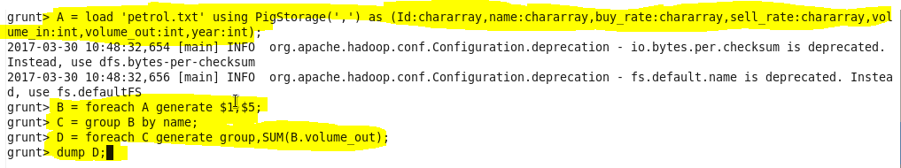

**Output:**

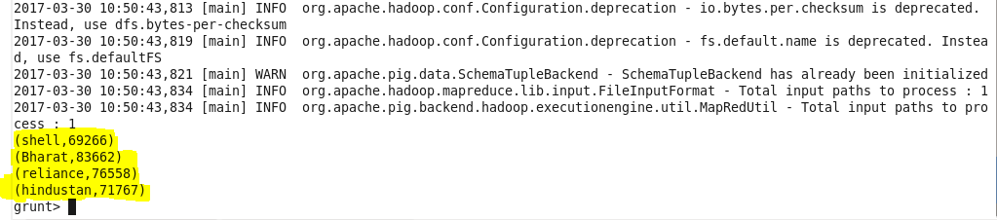

1. **Which are the top 10 distributors ID's for selling petrol? Also display the amount of petrol sold in volume.**

**Code:**

A = load ‘petrol.txt’ using PigStorage(‘,’)as (id:chararray,name:chararray,buy_rate:chararray,sell_rate:chararray,volume_in:int,volume_out:int,year:int);

B= foreach A generate $0,$5;

C = group B by Id;

D = foreach C generate group,SUM(B.volume_out);

E = order D by $1 desc;

F = limit E 10;

Dump F;

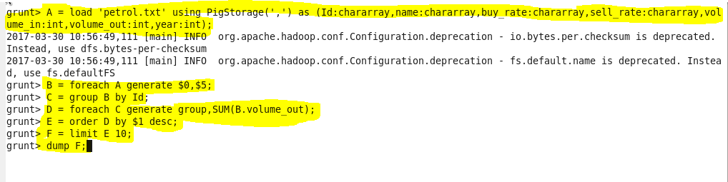

**Output:**

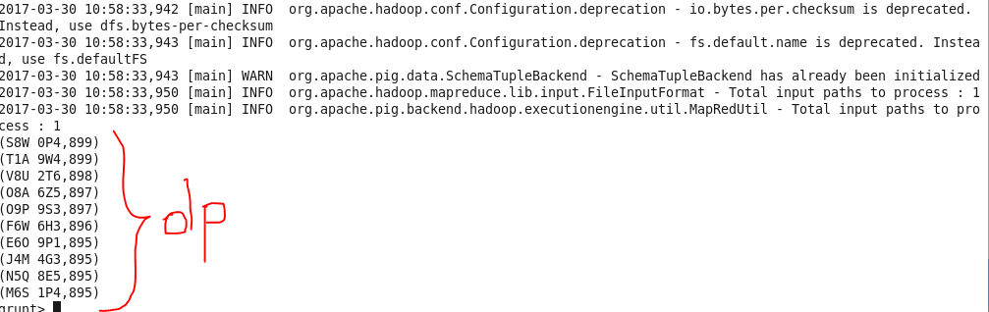

1. **List 10 years where consumption of petrol is more with the distributer id who sold it.**

**Code:**

A = load ‘petrol.txt’ using PigStorage(‘,’)as (id:chararray,name:chararray,buy_rate:chararray,sell_rate:chararray,volume_in:int,volume_out:int,year:int);

B = foreach A generate $0,$5,$6;

C = group B by year;

D = foreach C generate group,B.Id as id,MAX(B.volume_out) as max;

E = order D by max desc;

F = limit E 10;

Dump F;

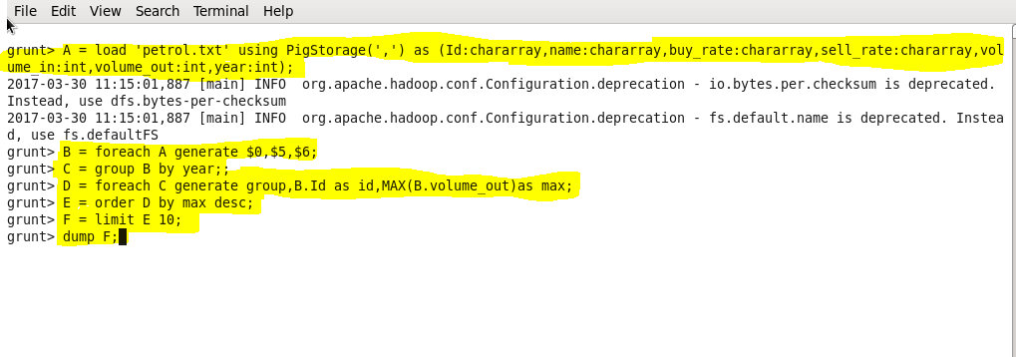

**Output:**

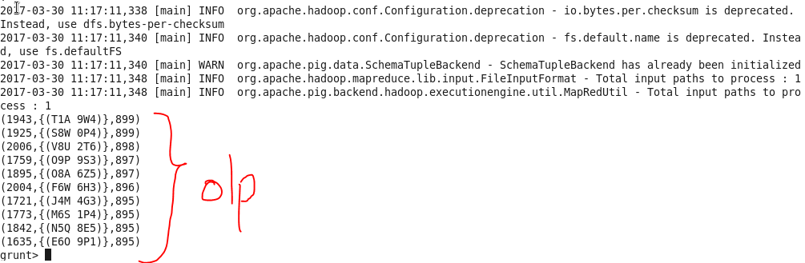

1. **Find the distributer name who sold petrol in least amount.**

**Code:**

A = load ‘petrol.txt’ using PigStorage(‘,’)as (id:chararray,name:chararray,buy_rate:chararray,sell_rate:chararray,volume_in:int,volume_out:int,year:int);

B= foreach A generate $1,$5;

C = group B by name;

D = foreach C generate group,SUM(B.volume_out);

E = order D by $1 ;

F = limit E 1;

Dump F;

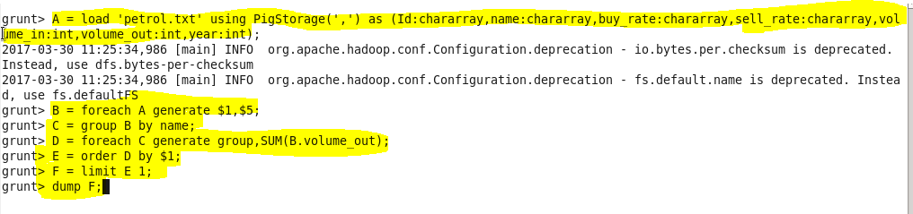

**Output:**

